Article Title (Capital each word, 14 point font, boldface, centered, max 21 words)
Submissions Template for Authors – Jurnal Keperawatan Respati Yogyakarta Yogyakarta

Author's Name¹, Author's Name², Author's Name³ (12pt Bold)
¹Corresponding author affiliation, with address and Name of country
²Corresponding author affiliation, with address and Name of country
³Corresponding author affiliation, with address and Name of country

Abstract (10 pt, italic )

The abstract must be in English containing the core of the problem to be raised, the contribution, and method of its solution, and the scientific findings obtained and conclusions. Abstract written in italics (Italic) along 150-200 words. The text is written with a 35 mm left margin and a 30 mm right margin with a font size of 10 pt and Times New Roman font and a line spacing.

Keywords: Keyword 1; Keyword 2; Keyword 3 (10 pt, font italic)
-------------------------------------------------------------
*) Corresponding author:
E-mail :

1. Introduction
Manuscripts are written in English with a maximum number of 12 pages including pictures and tables. Manuscripts should be written according to the template of this article in the form of print ready (Camera ready). Articles must be written with A4 writing size (210 x 297 mm) and with a format of 25 mm left margin, 20 mm right margin, 20 mm bottom margin, and 30 mm top margin. The manuscript must be written in Times New Roman font with a font size of 10 pt (except the title of the article, the name of the author and the title of the abstract), spaced one space, and in the format of one column with 1 space.
Article title, author's name (without an academic degree), and author's affiliate address are centered on the first page under the article title. The distance between the lines between the title and the author's name is 2 spaces, while the distance between the author's affiliate address and the abstract title is 1 space. Keywords must be written below the abstract text for each language, arranged in alphabetical order and separated by semicolons with 3-5 words. The Corresponding Author must be marked with an asterisk followed by a comma "*)". At the bottom of the left column of the first page / abstract, you must write the Corresponding Author and also write the email address (see example). Communication about article revisions and final decisions will only be communicated via the Author's Correspondence email. If the author is more than one, write down the names of the authors separated by commas (,). If the author's name consists of two words, the first word of the author (first name) should not be abbreviated.
The script writing format uses the American Psychological Association 6th Edition (APA) manual style. The author's last name and year of publication for the source must appear in the text, for example, (Rizqi, 2019), and the full reference must appear in the reference list at the end of the paper. Writing quotations can be at the beginning of a sentence for example Muflih (2010) or at the end of a sentence (Ningrum, 2004).
The introduction must contain (in sequence) a general background, a prior literature review (state of the art) as a basis for the statement of scientific renewal of the article, a statement of scientific renewal, and a research problem or hypothesis. At the end of the introduction the objectives of the article should be written. In the scientific article format it is not permissible to review the literature as in the research report, but is realized in the form of a previous literature review (state of the art) to show the scientific novelty of the article.

2. Method (Font: Times New Roman with a font size of 10 pt, spaced one space, and in one column format)
Materials and research methods contain the main ingredients or instruments (equipment) used in research. The materials written here are only the main material and must be equipped with the brand and purity (for example: NaCl (Otsuka, 0.9%, Spigmomanometer (Omron)). Small and non-main tools do not need to be written down (it is common in the lab, for example: scissors, measuring cup, pencil) Research methods are written in full and detailed such as research design, place and time of study, population and sample, data measurement, and data analysis methods experimental procedures must be written in sentence form news, not a command sentence. The main set of tools should be presented in this section supplemented with picture captions.

3. Results and Discussion
The results and discussion contain the results of research findings and scientific discussions. Write scientific findings (scientific finding) obtained from the results of research that has been done but must be supported by adequate data. The scientific findings referred to here are not the research data obtained. Scientific findings must be explained scientifically include: Are scientific findings obtained? Why did that happen? Why is the trend variable like that? All of these questions must be explained scientifically, not only descriptive, if necessary supported by adequate basic scientific phenomena and nursing theories that underlie them. In addition, it should be explained also comparison with the results of other researchers who are almost the same topic. Research results and findings must be able to answer the research hypotheses in the introduction.
Tables and figures are made separately at the end (Format changes will be made by the TIM editor). Images must be guaranteed to print clearly (font size, resolution and line size must be sure to print clearly). Figures and tables and diagrams / schemes should be placed in columns between groups of text or if they are too large placed in the middle of the page. Tables should not contain vertical lines, horizontal lines are allowed but only important ones. To refer to the table or picture, please write it at the end of the sentence, for example (Table 1 / Figure 1) or it can also be written at the beginning of a sentence such as "Table 1 / Figure 1 shows ..."

4. Conclusions and Suggestions
The conclusions describe the answers to the hypotheses and/or research objectives or scientific findings obtained. Conclusions do not contain a repeat of the results and discussion, but rather a summary of the findings as expected in the objectives or hypotheses. If necessary, at the end of the conclusion can also be written things that will be done related to the ideas (suggestions) further from the research. Suggestions may be added in conclusions (not required) but written in paragraph form.

5. Acknowledgments (if any)
Acknowledgments are especially addressed to research funders or donors. Acknowledgments can also be conveyed to the important parties who helped carry out the research.

6. References
All references referred to in the article text must be registered in the Bibliography section. Bibliography must contain reference libraries originating from primary sources (100% scientific journals in English) published in the last 5 (five) years. Each article contains at least 20 (twenty) references. Writing a reference system in the text of the article and writing a bibliography we highly recommend using a reference management application program for example: Mendeley, EndNote, or Zotero, or others.
The writing format used in the journal is in accordance with the APA 6th Edition (American Psychological Association) format. Examples of bibliography formats from Journal:
Library in the form of scientific magazines / journals:
Bao, W. (2020). COVID‐19 and online teaching in higher education: A case study of Peking University. Human behavior and emerging technologies, 2(2), 113-115.

Here is an example Table:

Table 1. Frequency Distribution of Respondent Characteristics
(Font: Times New Roman, one space with a font size of 10 pt)

Characteristics | Frequency (f) | Percentage (%)
Age
46-55 tahun | 11 | 34.4
56-65 tahun | 5 | 15.6
Gender
Men | 17 | 53.1
Women | 15 | 46.9

Here is an example Figure:

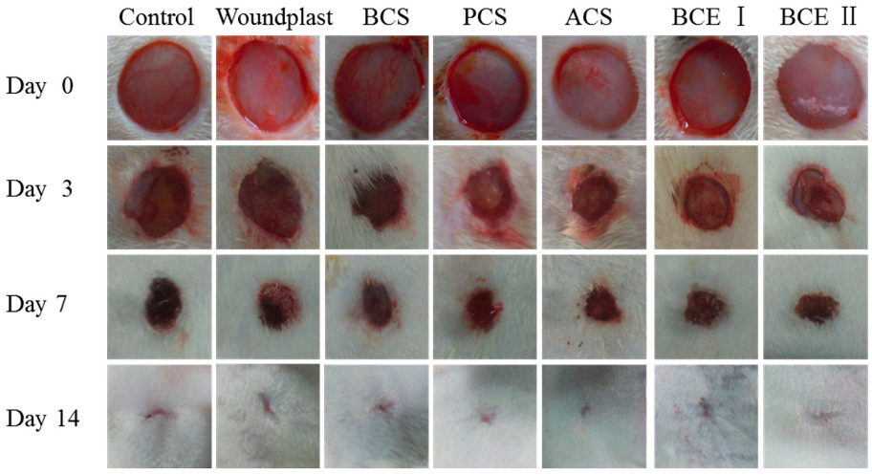

Figure 1. Example graphic / picture
(Font: Times New Roman, one space with a font size of 10 pt)

